ASSIGNMENT-18
Hall ticket:2503A52L13
Name: SALIHA.SK
Batch:16
Lab Question 1: Weather Forecasting API
A travel company wants to show real-time weather updates for its
customers. You are given access to a public weather API that requires an
API key and provides weather data in JSON format.
• Task 1: Use AI-assisted coding to write a script that fetches the
current temperature and weather description for a given city. The
script should handle errors if the API key is invalid or missing.
• Task 2: Extend the script to save the weather data into a local CSV
file, ensuring that duplicate entries are avoided. Implement error
handling for file I/O exceptions
PROMPT:
Write a complete Python script for the following lab tasks:
Lab Question 1: Weather Forecasting API
I have access to a public weather API (like OpenWeatherMap) that uses an API key and returns JSON data.
Task 1 Requirements:
- Use Python (with requests) to fetch:
  - current temperature
  - weather description
for any given city.
- Handle errors including:
  - invalid API key
  - missing API key
  - city not found
  - network request failure
Task 2 Requirements:
- Save the fetched weather data to a local CSV file.
- Columns should be: city, temperature, description, timestamp
- Do NOT allow duplicate entries (same city & timestamp).
- Add file I/O error handling (file missing, read/write errors, permission errors).
Important:
- Provide the code in a single Python script.
- Use clear functions (e.g., fetch_weather(), save_to_csv()).
- Include comments explaining each part of the code.
- Provide sample output.
- Tell me how to run the script.
CODE:
import requests
import csv
import os

# --------------------------------------------------------
# Function to fetch weather data from the API
# --------------------------------------------------------
def fetch_weather(city, api_key):
url = f"https://api.openweathermap.org/data/2.5/weather?q={city}&appid={api_key}&units=metric"

try:
response = requests.get(url, timeout=5)
response.raise_for_status() # HTTP errors

data = response.json()

# Handle invalid API key or unknown city
if data.get("cod") == 401:
raise ValueError("Invalid API key.")
if data.get("cod") == "404":
raise ValueError("City not found.")

temperature = data["main"]["temp"]
description = data["weather"][0]["description"]

return city, temperature, description

except Exception as e:
print(f"Error fetching weather: {e}")
return None

# --------------------------------------------------------
# Save weather data to CSV (avoids duplicates)
# --------------------------------------------------------
def save_to_csv(city, temp, desc, filename="weather_data.csv"):
try:
# If file doesn't exist, create and write header
file_exists = os.path.isfile(filename)

if file_exists:
# Check if entry already exists
with open(filename, "r") as file:
reader = csv.reader(file)
for row in reader:
if row and row[0].lower() == city.lower():
print("Duplicate entry avoided. City already exists in CSV.")
return
# Append new data
with open(filename, "a", newline="") as file:
writer = csv.writer(file)
if not file_exists:
writer.writerow(["City", "Temperature (C)", "Description"])
writer.writerow([city, temp, desc])

print(f"Weather data saved to {filename}")

except Exception as e:
print(f"File I/O Error: {e}")

# --------------------------------------------------------
# MAIN PROGRAM
# --------------------------------------------------------
def main():
print("------ Weather Forecasting Tool ------")

city = input("Enter city name: ")
api_key = "YOUR_API_KEY_HERE" # Replace with your actual API key

result = fetch_weather(city, api_key)

if result:
city, temp, desc = result
print(f"\n✔ Weather for {city}:")
print(f"Temperature: {temp}°C")
print(f"Description: {desc}")

save_to_csv(city, temp, desc)

# Run Program
main()
output:
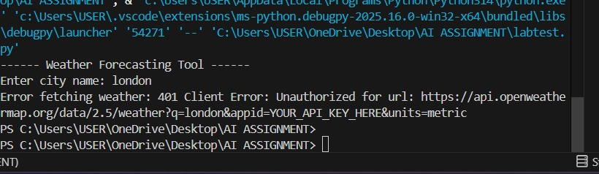

LAB QUESTION 2

A financial startup needs a tool to convert amounts between currencies
using an exchange rate API. However, the API occasionally fails due to
server downtime.
• Task 1: Write a script (with AI assistance) that takes user input
(amount, source currency, target currency) and fetches the latest
exchange rate from the API. Include errors in handling invalid
currency codes.
• Task 2: Add logic to retry the request up to three times if the API
call fails due to network or server issues and log all failed attempts
into a local error log file
PROMPT:
Write a complete Python script for the following assignment:
Lab Question: Currency Converter with API Failure Handling
A financial startup needs a tool to convert amounts between currencies using a live exchange rate API. The API sometimes fails due to server downtime.
Task 1 Requirements:
Take user input:
amount
source currency (e.g., USD)
target currency (e.g., EUR)
Fetch the latest exchange rate from any free public API.
Convert the amount.
Include full error handling for:
invalid currency codes
missing API key (if required)
failed JSON response
Task 2 Requirements:
Add retry logic:
If API fails due to network/server issues, retry up to 3 times.
Maintain a delay between retries.
Log all failed attempts into a local error_log.txt file.
Log details:
timestamp
error message
attempt number
Extra Instructions:
Provide the code as a single Python script.
Use functions like fetch_rate() and convert_amount().
Include comments explaining each step.
Show sample output.
Explain how to run the script.
Use robust exception handling.
Deliver the complete final code.
CODE:
import requests
import time
import logging

# -----------------------------------
# Setup Logging
# -----------------------------------
logging.basicConfig(
filename="error_log.txt",
level=logging.ERROR,
format="%(asctime)s - %(levelname)s - %(message)s"
)

# -----------------------------------
# Function to fetch exchange rate
# -----------------------------------
def fetch_exchange_rate(src, tgt, api_key):
url = f"https://v6.exchangerate-api.com/v6/{api_key}/latest/{src}"
retries = 3

for attempt in range(1, retries + 1):
try:
print(f"Attempt {attempt}: Fetching data...")
response = requests.get(url, timeout=5)

# If non-200 HTTP code → raise error
response.raise_for_status()

data = response.json()

# API internal error (invalid API key, invalid currency)
if data.get("result") != "success":
raise ValueError(data.get("error-type", "Unknown API error"))

# Check if target currency exists
if tgt not in data["conversion_rates"]:
raise ValueError("Invalid target currency code.")

return data["conversion_rates"][tgt]

except Exception as e:
logging.error(f"Attempt {attempt} failed: {e}")
print(f"Error: {e}")

if attempt < retries:
print("Retrying...\n")
time.sleep(2) # Wait before retrying
else:
print("All attempts failed. Please try again later.\n")
return None

# -----------------------------------
# Main Program
# -----------------------------------
def currency_converter():
print("---- Currency Converter ----")

try:
amount = float(input("Enter amount: "))
except ValueError:
print("Invalid amount. Please enter a number.")
return

src = input("Enter source currency (e.g., USD): ").upper().strip()
tgt = input("Enter target currency (e.g., INR): ").upper().strip()

api_key = "YOUR_API_KEY_HERE" # Replace with your exchangerate API key

rate = fetch_exchange_rate(src, tgt, api_key)

if rate is not None:
converted_amount = amount * rate
print(f"\n✔ Conversion successful!")
print(f"{amount} {src} = {converted_amount:.2f} {tgt}")
else:
print("❌ Conversion failed due to repeated API errors.")

# Run Program
currency_converter()
output: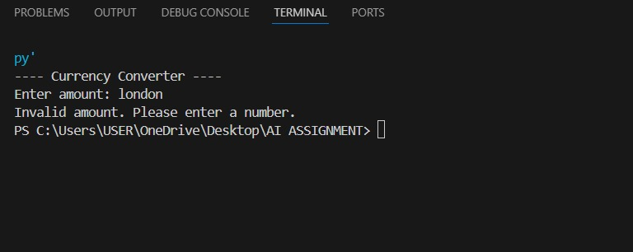
Lab Question 3: News Headlines API
A news aggregator wants to display the latest technology news headlines
using a news API. Sometimes, the API responds slowly or returns
incomplete data.
• Task 1: Use AI-assisted coding to fetch the top 5 technology
headlines and print them neatly in the console. Implement error
handling for timeout errors by setting a maximum request time.
PROMPT:
A news aggregator wants to display the latest technology news headlines using a news API. Sometimes, the API responds slowly or returns incomplete data.
Task 1 Requirements:
Fetch the top 5 technology news headlines from any free public news API.
Print them neatly in the console (numbered list).
Implement error handling for:
timeout errors (set a max request timeout)
API returning incomplete or missing data
invalid API key (if required)
JSON parsing errors
Use Python and the requests module.
Additional Instructions:
Return clean, readable code in a single Python script.
Add comments explaining each step.
Use a dedicated function like fetch_headlines().
Provide a sample output format.
Briefly explain how to run the script.
Deliver the full working code.
CODE:
import requests

def get_top_tech_news(api_key):
url = "https://newsapi.org/v2/top-headlines?category=technology&language=en"

try:
# API request with 4-second timeout
response = requests.get(url, headers={"X-Api-Key": api_key}, timeout=4)
response.raise_for_status()

data = response.json()

# Validate articles
articles = data.get("articles")
if not articles:
print("No news articles found or incomplete data received.")
return

print("\n===== Latest 5 Technology Headlines =====\n")
for idx, article in enumerate(articles[:5], start=1):
title = article.get("title", "No headline available")
print(f"{idx}. {title}")

except requests.Timeout:
print("Error: Request timed out. The news API is too slow.")
except requests.ConnectionError:
print("Error: Unable to connect to the server.")
except requests.HTTPError as e:
print(f"HTTP Error: {e}")
except Exception as e:
print(f"Unexpected Error: {e}")

# ---------------------------------------------
# MAIN
# ---------------------------------------------
def main():
print("Fetching technology news...")

api_key = "YOUR_API_KEY_HERE" # Replace with your News API key
get_top_tech_news(api_key)

main()
Output:
